Lab 6: Secure Communication System Using Public Key Cryptography
Cybersecurity Architecture, Design, and Secure Software Development
Name: Daffiniruby Peter Arockiasamy
Task 1: Security Design Decision

Selecting an appropriate encryption key size is an important part of protecting healthcare information. Hospitals store patient records for many years, so the security method used to protect this information should remain reliable over a long period. At the same time, the encryption method should not create too much processing overhead for hospital applications and connected devices.
For RSA, 2048 bits can be considered the minimum acceptable size, while RSA-3072 is a stronger choice for new healthcare applications. RSA-2048 provides around 112 bits of security strength, whereas RSA-3072 provides around 128 bits. Smaller RSA keys, such as 1024 bits, are no longer suitable for protecting sensitive information. Since medical records may need to remain protected for decades, using RSA-3072 provides additional security compared with using the minimum key size.
There is a performance cost when larger RSA keys are used. Larger keys require more computational resources for operations such as key generation and cryptographic processing. This can become noticeable when a system has many users or devices communicating at the same time. However, RSA is generally not used to encrypt complete medical files because it is relatively slow for large amounts of data. Instead, healthcare systems can use hybrid encryption. RSA can be used for authentication and protecting a session key, while AES can be used to encrypt the actual patient information. This approach provides strong security without unnecessarily increasing the processing requirements.
Using AES by itself also creates a problem during the initial communication. Both parties need to possess the same secret key before they can securely communicate. Sharing that key over an untrusted network could expose it to an attacker. Managing many shared keys also becomes difficult as the number of hospital systems and devices increases. Asymmetric cryptography helps solve this problem because public keys can be distributed while private keys remain protected. RSA or Diffie-Hellman can therefore be used to establish secure communication before AES is used for the actual data transfer.
Overall, RSA-3072 is a suitable choice for new healthcare systems because it provides stronger long-term protection while keeping the performance overhead manageable. RSA-2048 may still be appropriate for systems that require compatibility with existing infrastructure. A hybrid design using asymmetric cryptography for authentication and key establishment together with AES for patient-data encryption provides a practical balance between security and performance.
Task 2: Hospital Identity Setup

Output:

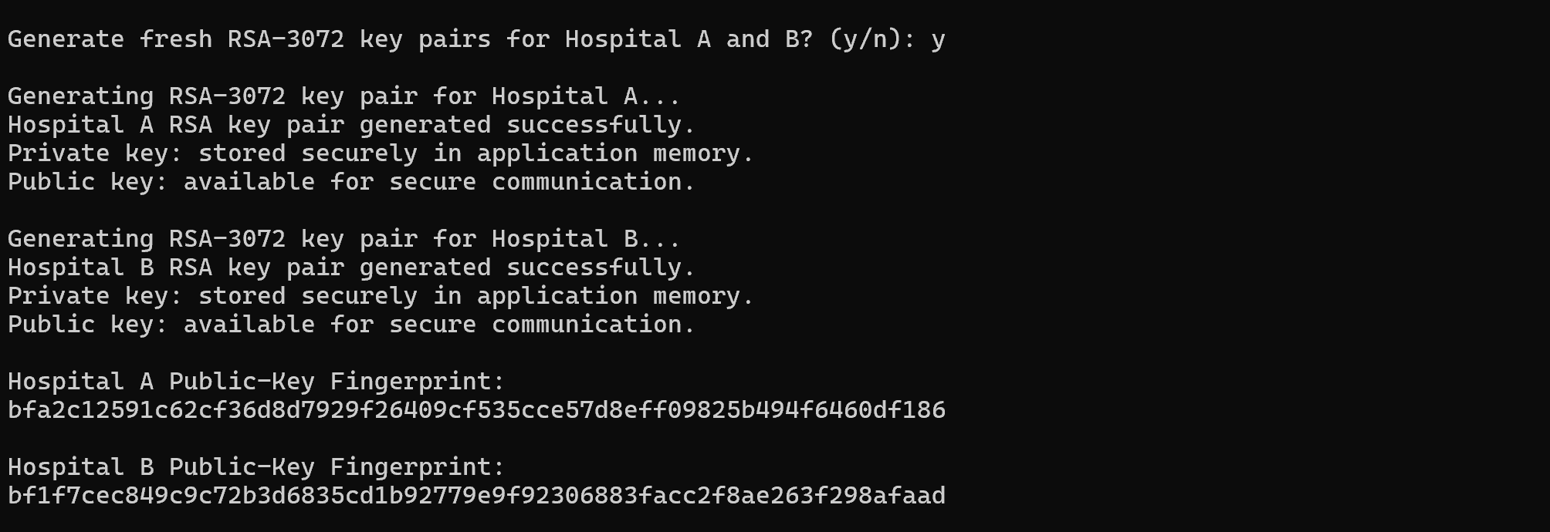

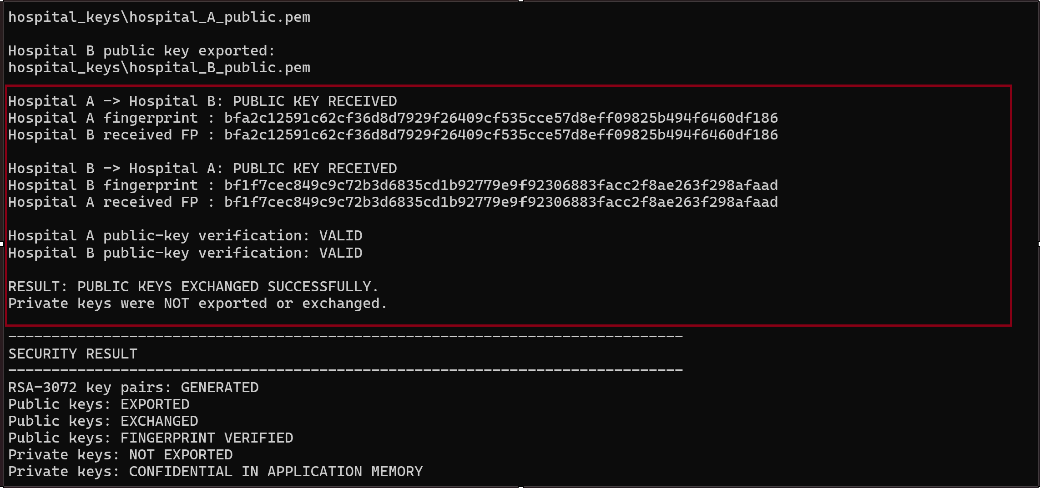

Explanation:
The key-generation process starts when Hospital A and Hospital B independently generate RSA key pairs using Python. Each hospital has two keys: a public key and a private key. The private key is kept confidential inside the application and is never shared with the other hospital. The public key is exported in PEM format and exchanged between Hospital A and Hospital B.
After receiving the other hospital’s public key, each hospital generates a SHA-256 from the key. The fingerprint is then compared with the trusted fingerprint to check whether the public key was changed during the exchange. If the fingerprints match, the public key is considered valid and can be used for secure communication. If the fingerprints do not match, the key is rejected because it may have been modified or replaced by an attacker. This process establishes the identity of both hospitals and prepares trusted public keys for the encryption, digital signature and secure key exchange tasks that follow.
Task 3: Confidential Patient Data Transfer
Security Analysis Report – Task 3: Confidential Patient Data Transfer
In this implementation, Hospital A sends the message “Patient ID 98321 requires immediate cardiac intervention.” The message is encrypted using Hospital B’s public key with RSA. After encryption, the message is converted into ciphertext and displayed in Base64 format. Hospital B then uses its private key to decrypt the ciphertext and get the original message.
The output shows that the encryption and decryption process was completed successfully. The original patient message is not directly visible in the ciphertext. After decryption, the same patient message is displayed again and the program shows the result as success. This confirms that the message was successfully encrypted using Hospital B’s public key and decrypted using Hospital B’s private key.
If an attacker intercepts the ciphertext during transmission, the attacker cannot directly read the original patient information. The attacker would need Hospital B’s private key to decrypt the ciphertext. Since the private key is kept confidential and is not shared with other parties, the patient information remains protected from unauthorized access.
RSA is not normally used to encrypt large medical datasets directly because RSA is slower and is mainly suitable for smaller amounts of data. In this method, AES-256 can be used to encrypt the actual medical data while RSA can be used to encrypt and securely transfer the AES session key.
Therefore, Task 3 demonstrates how asymmetric encryption can protect confidential patient information during communication. The implementation successfully shows encryption using the recipient’s public key and decryption using the recipient’s private key.
Output:
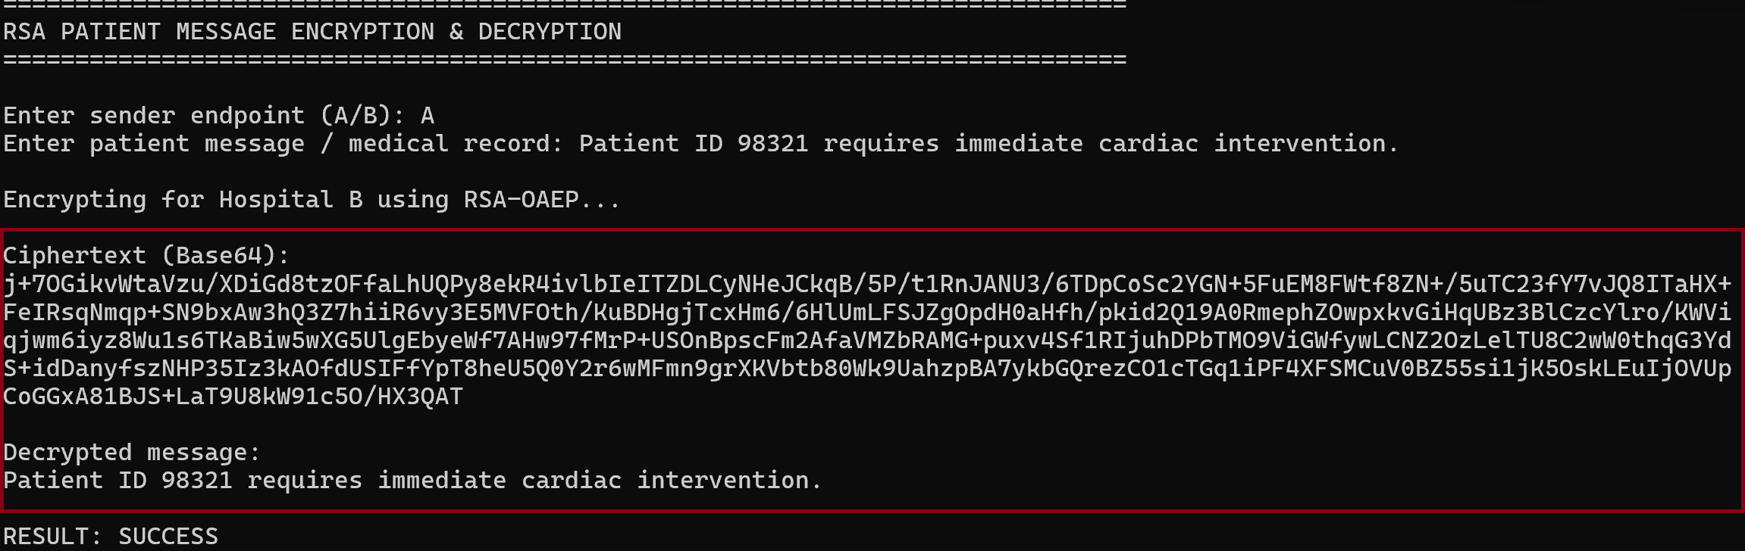

Task 4: Medical Authentication System

The original medical result “Glucose level: 6.5 mmol/L” was digitally signed using the sender’s private key. To demonstrate tampering, the value was changed to “Glucose level: 16.5 mmol/L” without changing the original signature. The modified message was then submitted for signature verification using the sender’s public key. Since the modification changed the SHA-256 hash of the message, the original signature no longer matched the received message. The system therefore displayed “RESULT: TAMPERING DETECTED” and reported that signature verification failed. This confirms that the digital signature successfully detected the unauthorized modification of the medical result.
Output:

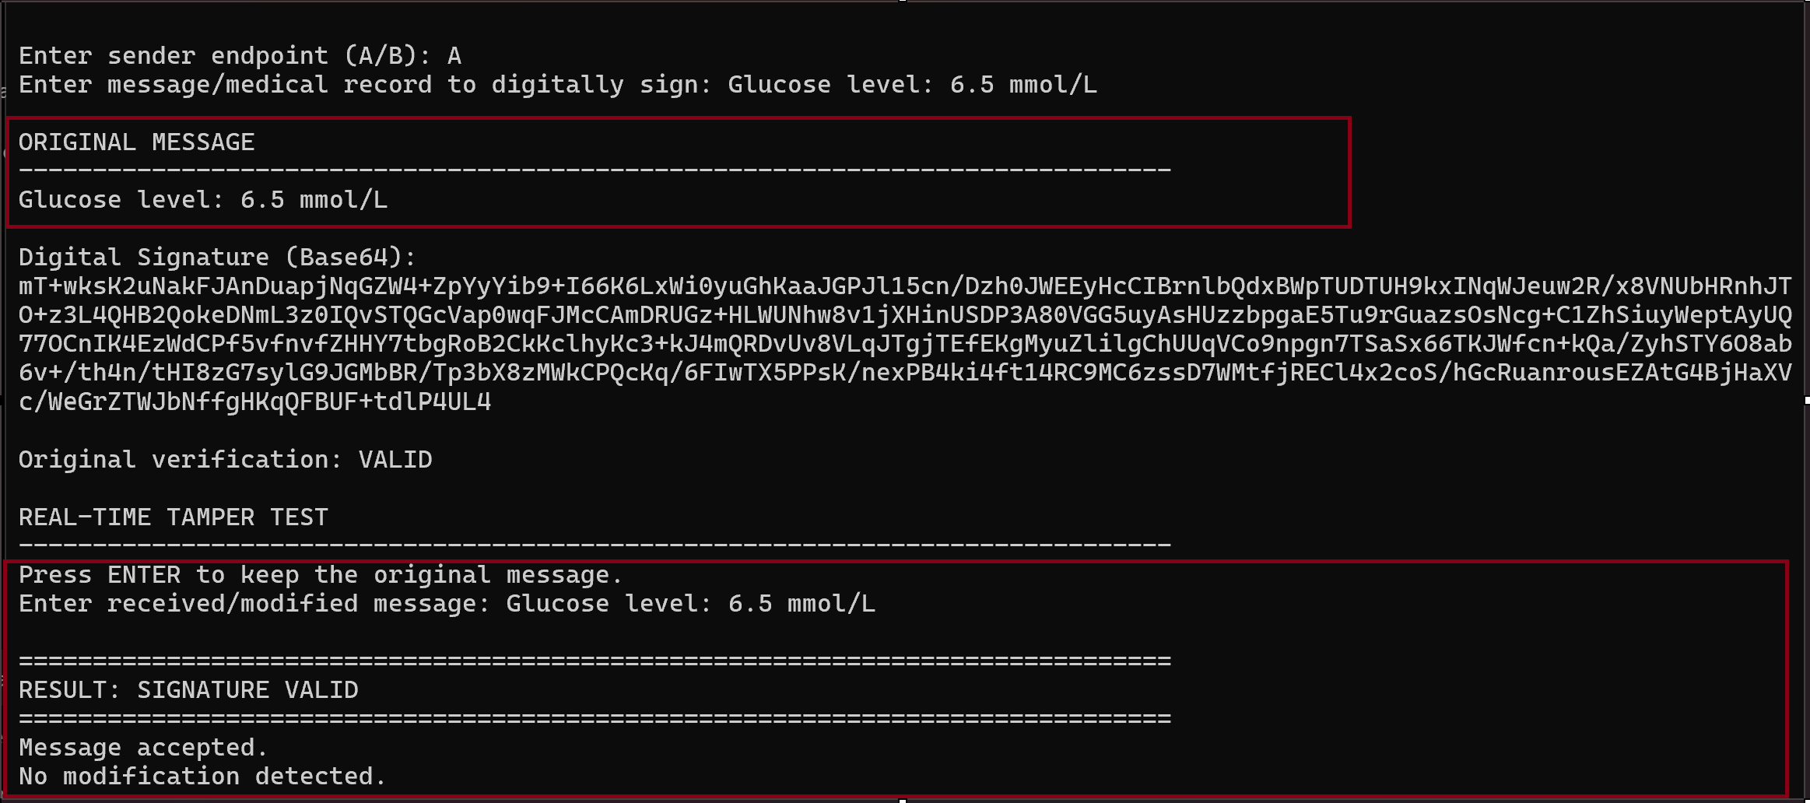
Part 5 — RSA-Based Key Exchange Design
The application provides an interactive demonstration of secure communication between Hospital A and Hospital B. First, Hospital A enters the patient record, and the system generates a new AES-256 session key. The patient information is then encrypted using AES-256. Since the AES key also needs to be transferred securely, it is encrypted using Hospital B’s RSA public key.
Hospital B uses its RSA private key to decrypt and recover the AES session key. The recovered AES key is then used to decrypt the patient record and obtain the original message. In the output, the decrypted message is the same as the message entered by Hospital A, and the system displays “Result: Hybrid Encryption Successful.”
This demonstrates why hybrid encryption is useful for secure communication. RSA is used to protect the session key, while AES-256 is used to encrypt the actual patient data. AES is more suitable for larger amounts of data because it is faster and more efficient than directly using RSA for the complete medical record.
Output:
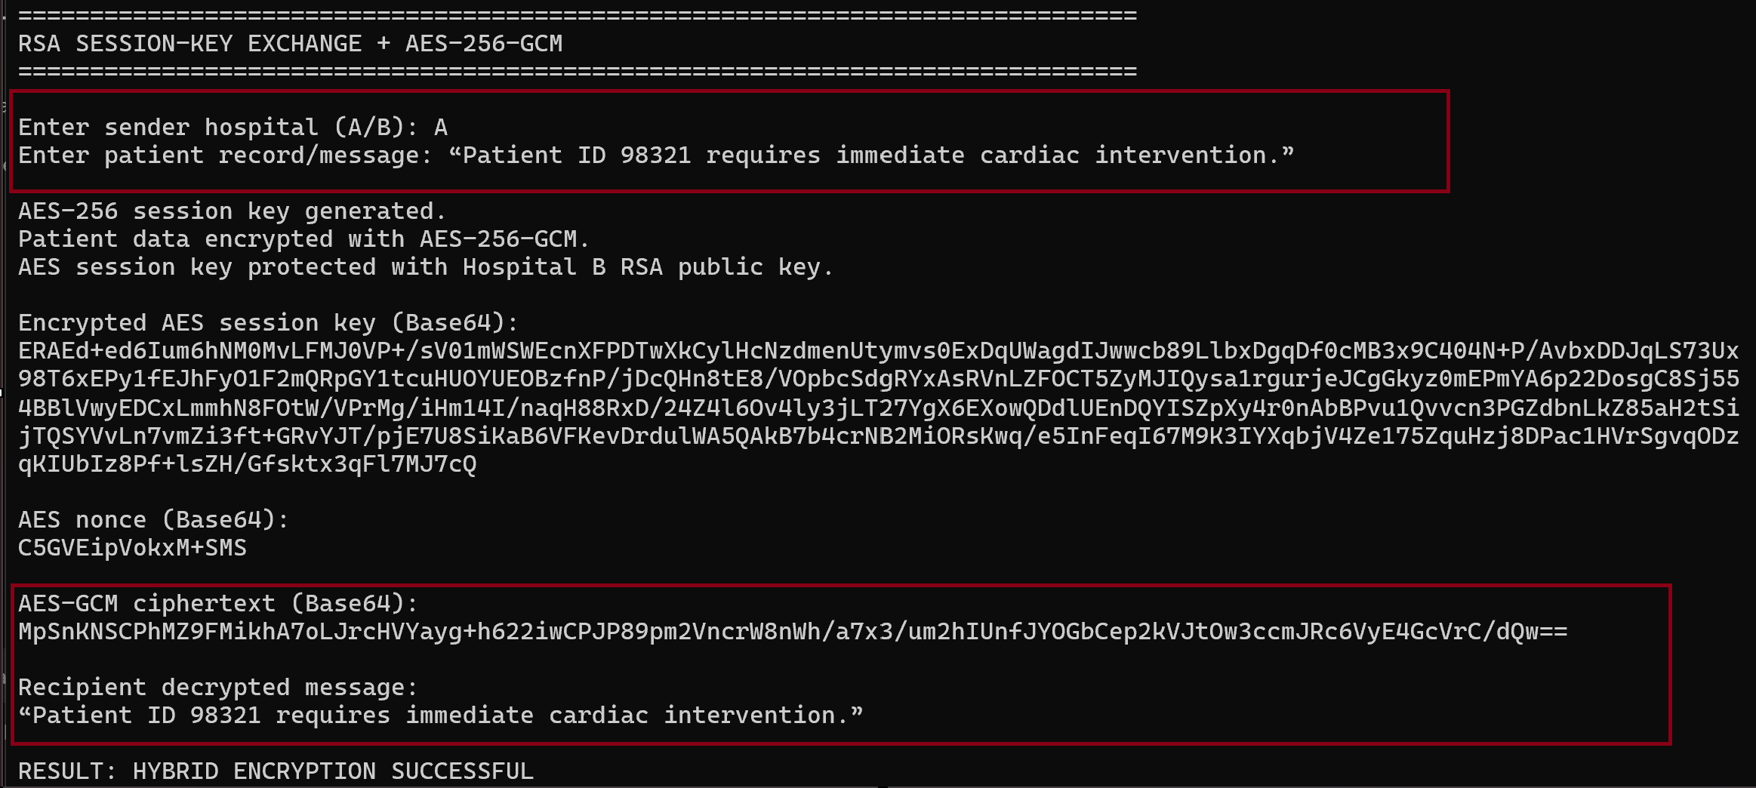
Part 6 — Diffie–Hellman Key Exchange
1.Why both sides generate the same key
Hospital A creates a private value and uses it with the public generator and prime to create its public value. Hospital B performs the same process using its own private value. The public values can be exchanged over the network because they do not reveal the private values directly.
Hospital A then uses Hospital B's public value together with its own private value to calculate the shared secret. Hospital B uses Hospital A's public value together with its own private value.
Therefore, both hospitals obtain the same shared secret without directly transmitting that secret. SHA-256 is then applied to the shared secret to derive the final 256-bit key.
2. Security Limitations
Although Diffie–Hellman allows two hospitals to establish a shared secret without directly sending the secret across the network, basic Diffie–Hellman does not authenticate the communicating parties. This creates a risk of a Man-in-the-Middle (MITM) attack. An attacker could potentially intercept the public values and establish separate shared keys with Hospital A and Hospital B.
Another limitation is that the private values must be generated using a secure random-number generator and must never be transmitted. The public parameters and implementation must also be configured correctly.
In a real healthcare environment, Diffie–Hellman should therefore be combined with authentication, digital certificates, digital signatures, or an authenticated protocol such as TLS. Modern systems would generally prefer authenticated Ecdh-based key exchange rather than using basic finite-field Diffie–Hellman directly.
Output:
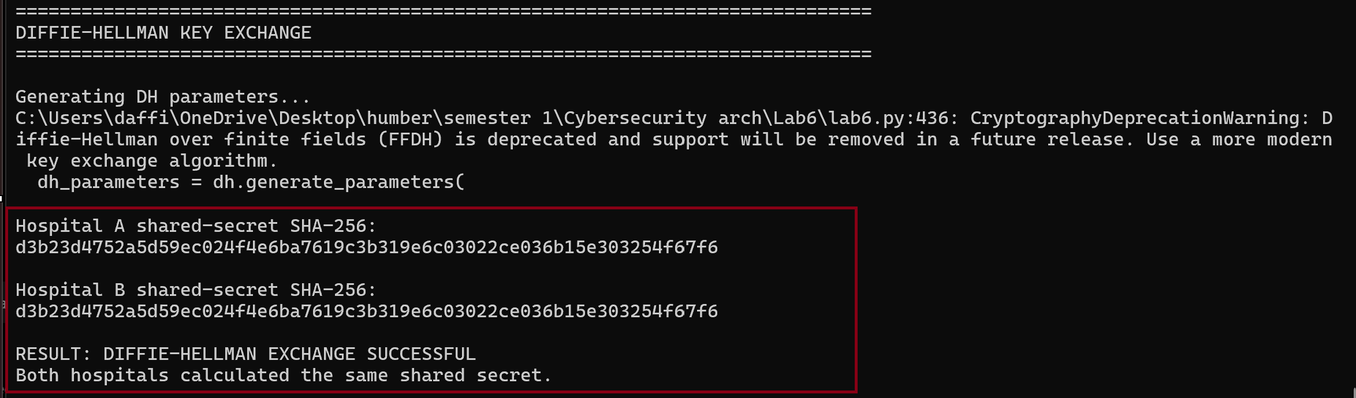
The execution output confirms that the Diffie–Hellman key exchange was successful. Hospital A and Hospital B generated different private values locally and exchanged only their public values. Both hospitals independently calculated the shared secret. The SHA-256 values displayed for both hospitals are identical: d3b23d4752a5d59ec024f4e6ba7619c3b319e6c03022ce036b15e303254f67f6
This confirms that both sides successfully derived the same key. The message “Result: Diffie-Hellman Exchange Successful” further confirms successful execution.

WorkFlow:
Rejected
Message accepted

No
Yes
Hospital used their private key to decrypt the text (Asymmetric Key)
Message has been encrypted as ciphered text
Exchange Public Keys
Hospital A sends its public keys to Hospital B and Viceversa

HOSPITAL A
Public Key & Private Key
HOSPITAL B
Public Key & Private Key
START

